Customer Relationship Management System

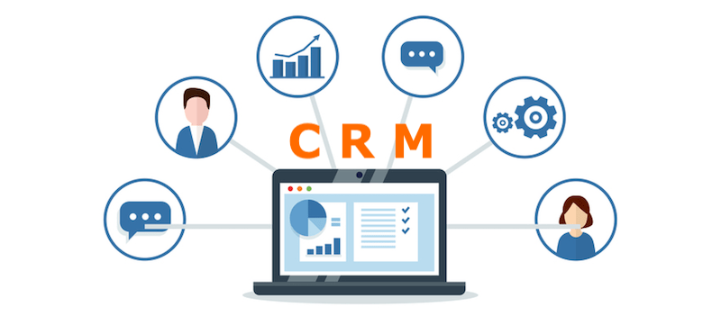

IST 659: DATABASE ADMINISTRATION CONCEPTS AND DATABASE MANAGEMENT SYSTEM

**Team: Data GenNext**

|  |  |
| --- | --- |
| Amesh Gharat | 414922819 |
| Aditya Shah | 747686910 |
| Manan Vora | 349846253 |

Table of Contents

1)Business Problem 1

2)Suggested Solution 1

3)Topic Selection 2

4)Identification of Data Logic 3

5)Conceptual Data Model 4

6)Logical Data Model 5

7)Application Screens 6

8)Script for the Database 9

9)Screenshot of Tables 14

10)Team Log 15

# Business Problem

Companies need to keep a track of their customers and customer activity. The employees of the company also need to keep tabs on their clients to make sure that all the production and financial needs of their clients are fulfilled. They also need to know which product was delivered to a particular client, through a salesman and at what price did the client purchased that item.

The company will also need to track the performance of their salesman considering the number of sales that the employee makes in a particular amount of time and the satisfaction of his/her clients. The employees also need to keep a track of the tasks they need to perform.

# Suggested Solution

The solution that Data GenNext has come up with to solve the above business problem is a database management system for the company in the form of a Customer Relationship Management System (CRM). The CRM was designed using MS SQL. This database consists of all the salient information about the employees (salesperson), orders, accounts, products, and tasks supposed to be done by employees. The database management system allows the administrator to store all the information about the above salient features. Also, the employees save up a lot of time as they can just access the CRM interface to keep track of the activities and requirements of the customers.

# Topic Selection

We selected the topic of Customer Relationship Management System as there has been a massive overhaul in the operations and functioning of many companies due to the global COVID-19 pandemic. More and more companies are shifting to remote working models and the in-person interactions between customers and their employees have become very unsafe and subsequently rare. Employees have started working remotely and almost the entire work has been shifted over to cloud-based systems. So, our team at Data GenNext has decided to design and implement a database management system in the form of a CRM. With the help of this CRM, customers and employees can interact with each other remotely without the necessity of meeting in person. In the same way, the employees of the company can keep track of their product dispatch, client requests, orders, tasks, and performance remotely. In this way, this CRM will allow interactions between employees and clients remotely with the risk of disease transmission. The main reason for the selection of this project was that we recognized the necessity and convenience of remote engagement.

# Identification of Data Logic

Throughout the project, we have implemented data logic like Procedures and Transactions. The procedures will be simplifying the process of denoting the completion of tasks in the database and assigning new tasks based on client requirements. Transactions are used to insert data into the tables. They are particularly helpful when inserting large amounts of data in one attempt. If there is an error in inserting any entry, the database rolls back to its original state without adding any more entries. We have also used joins to display multiple tables. The code for this logic can be found in the Script of Database section.

# Conceptual Data Model

|  |
| --- |
| Graphical user interface  Description automatically generated  PRIMARY KEY – FOREIGN KEY CONSTRAINTS IN THE TABLES:   1. Accounts:   PK – account_id FK – sales_team_id   1. Orders:   PK - order_id FK - account_id, product_id, sales_agent_id   1. Products:   PK – product_id   1. Tasks:   PK - task_id   1. Sales_Teams:   PK – sales_team _id   1. Employees:   PK - employee_id FK - sales_team_id   1. Employee_Tasks:   PK – task_id FK – employee_id |

# Logical Data Model

|  |
| --- |
|  |

# Application Screens

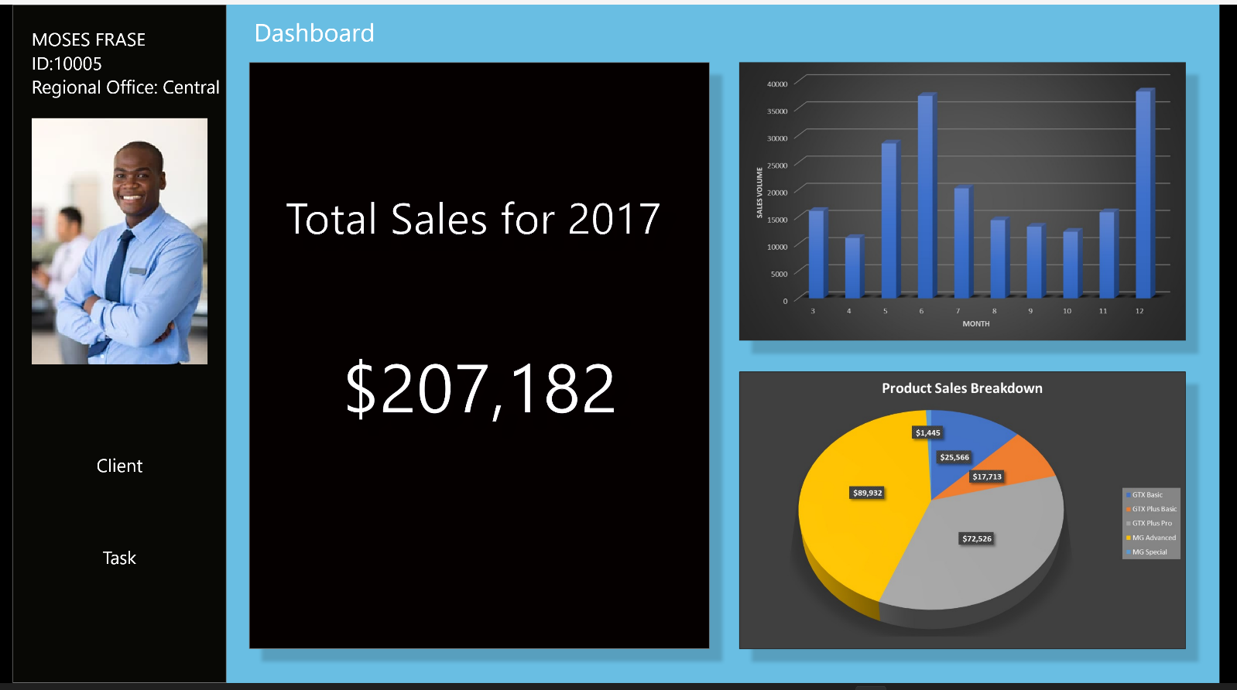

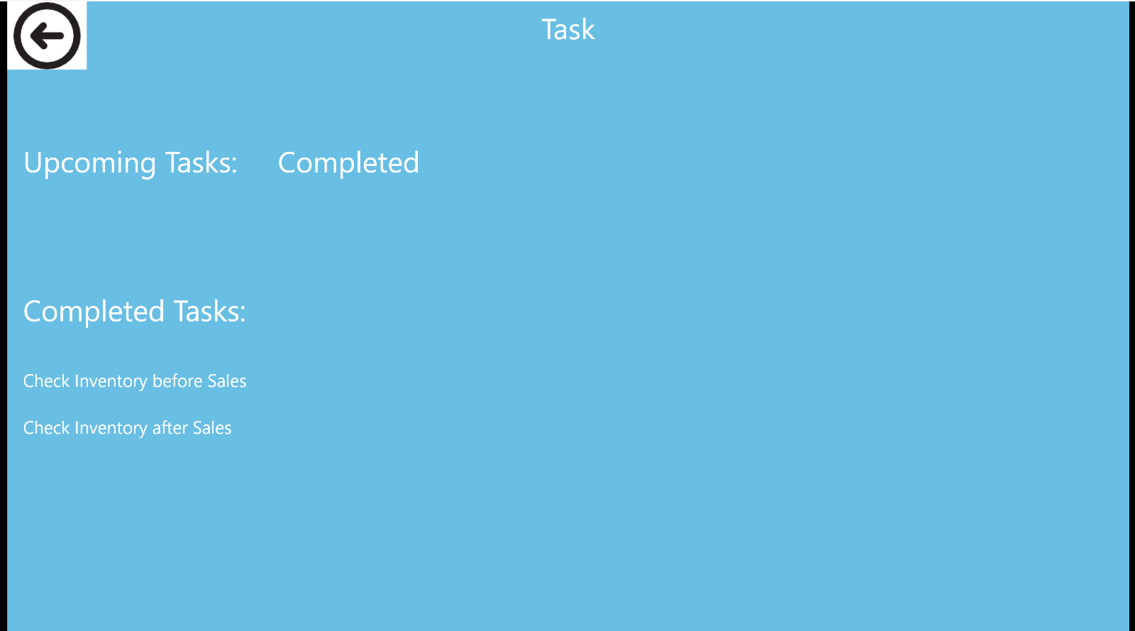

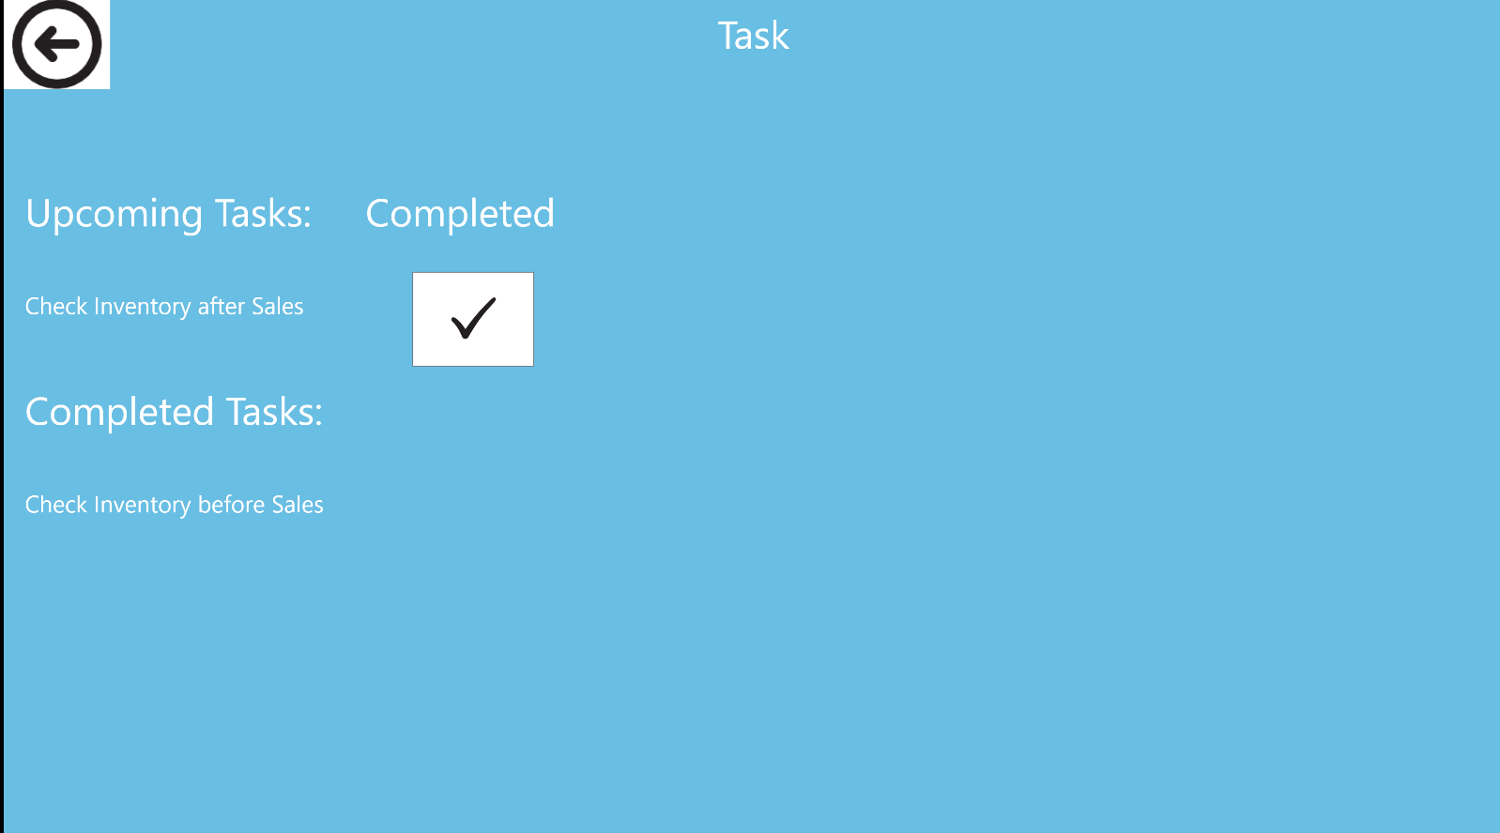

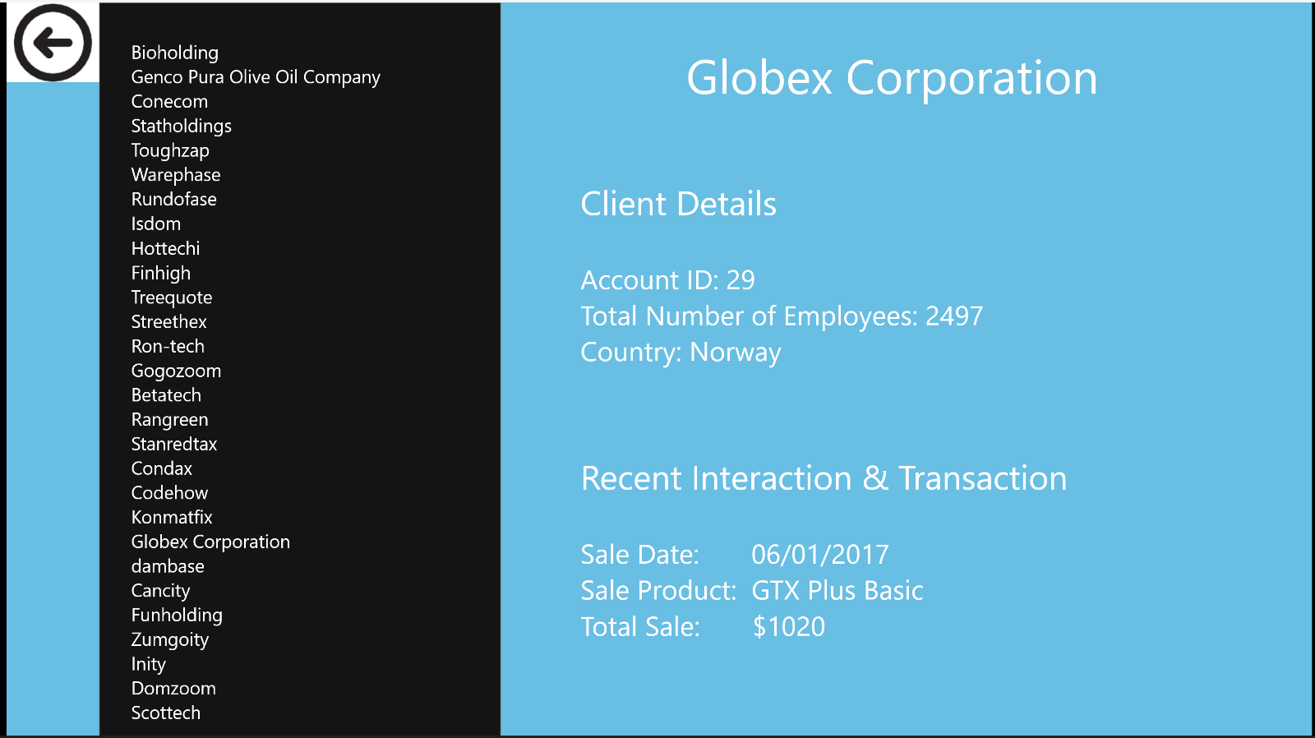

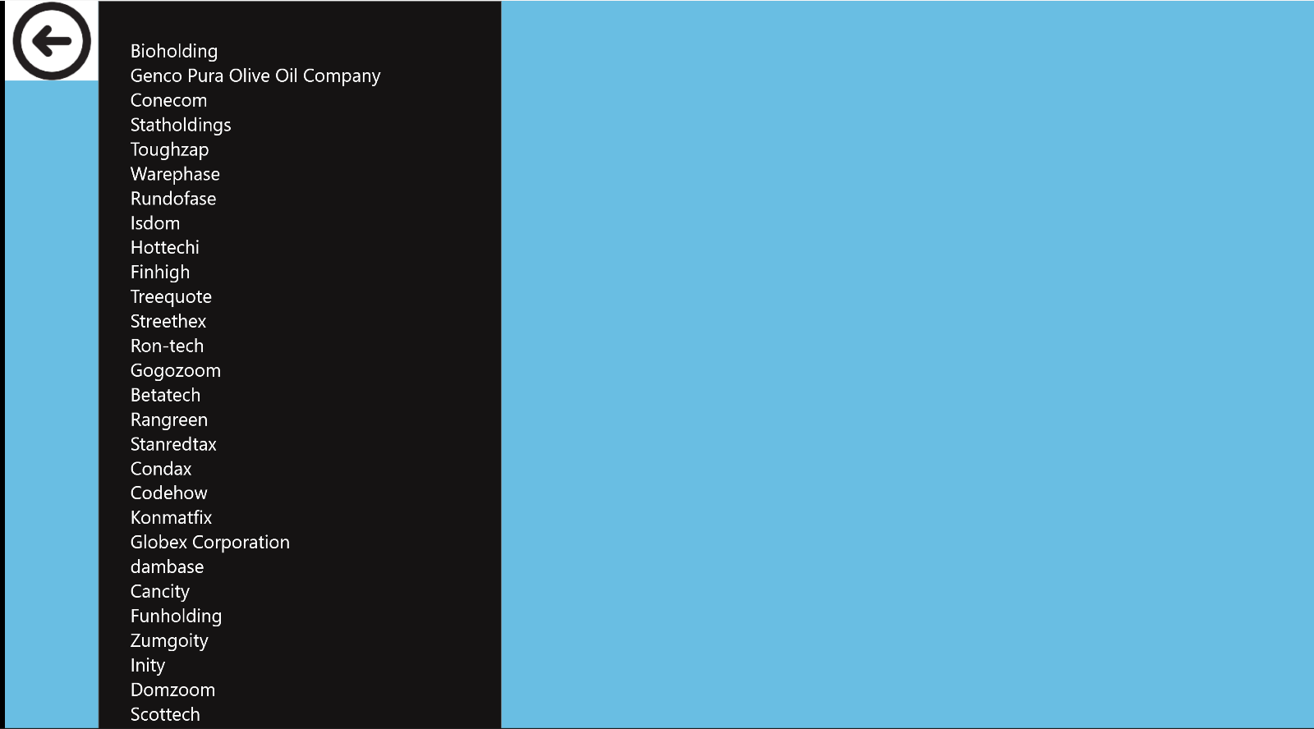

# Script for the Database

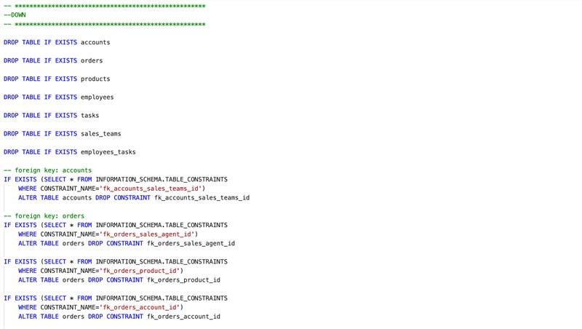

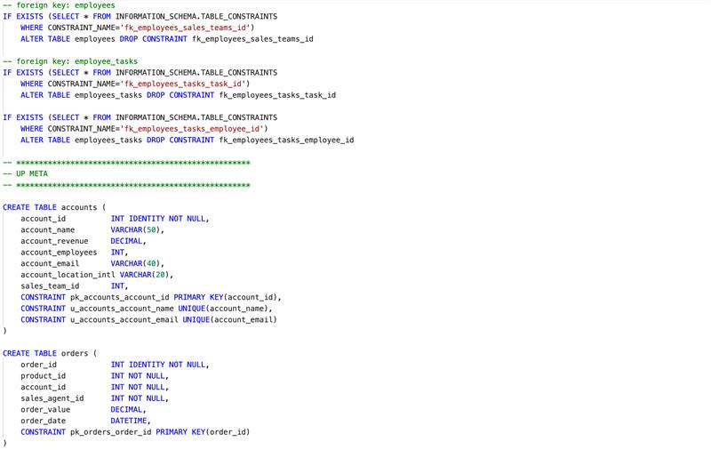

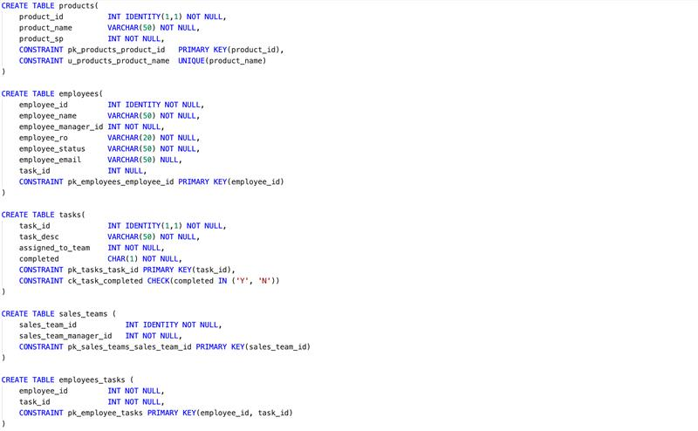

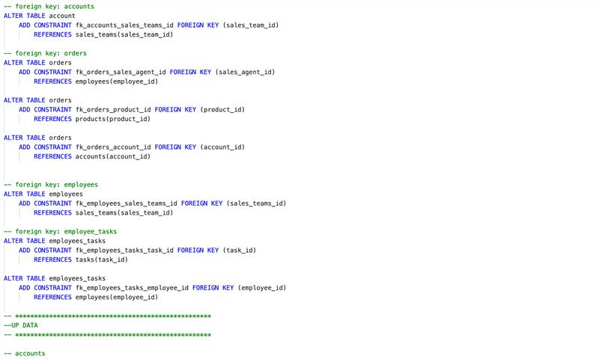

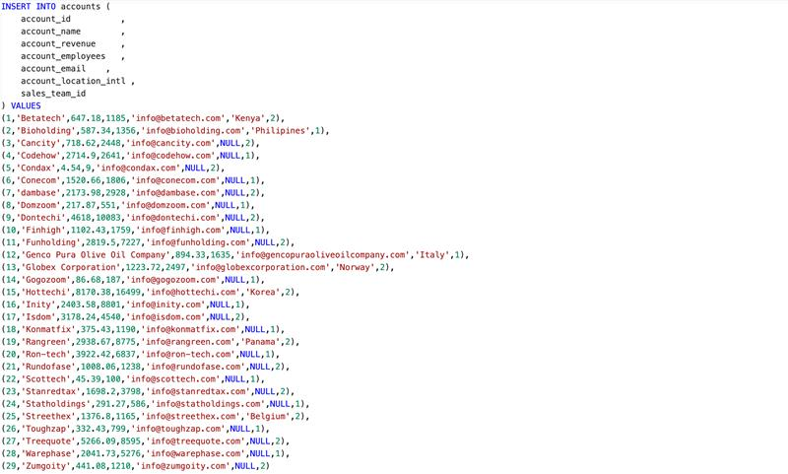

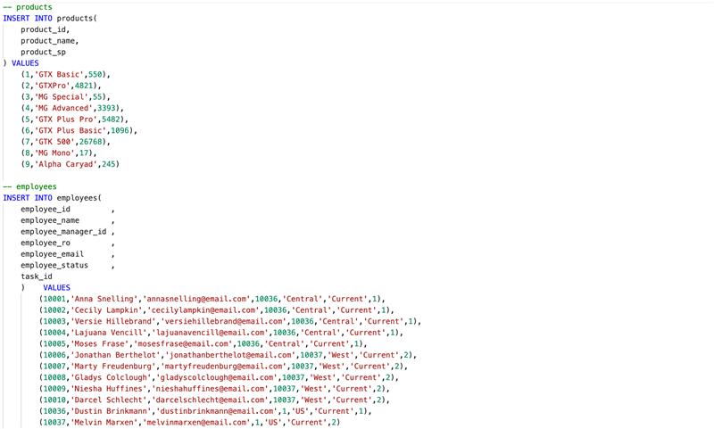

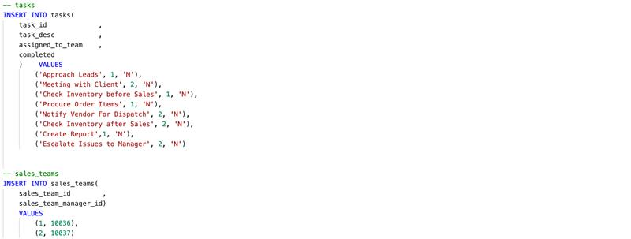

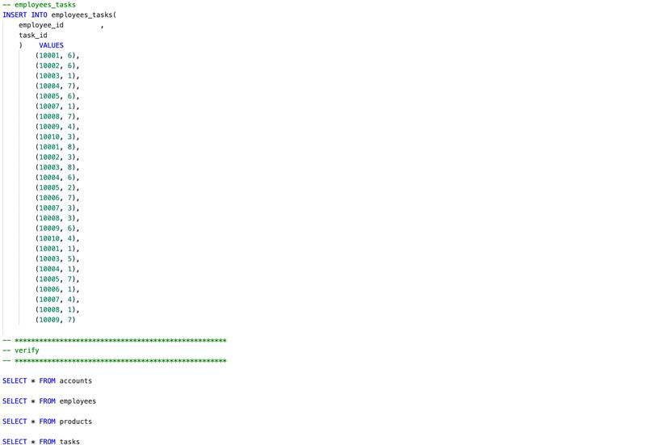



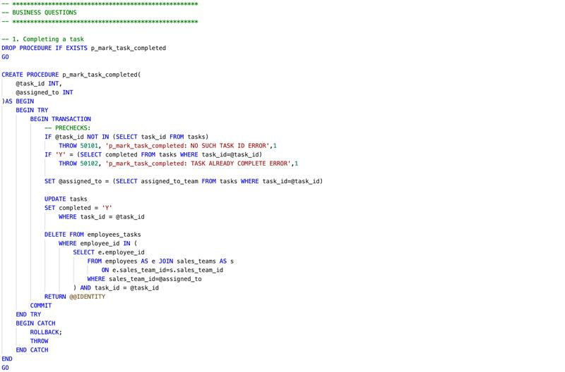

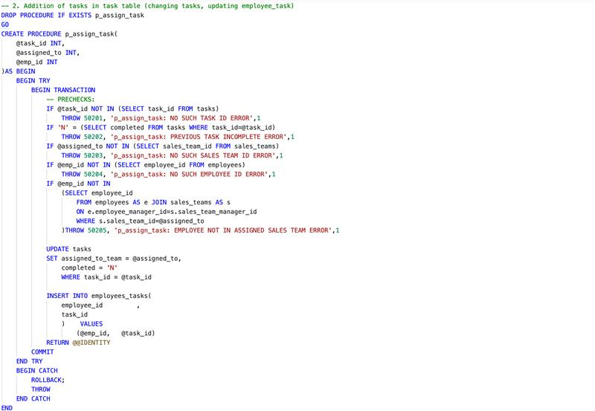

# Screenshot of Tables

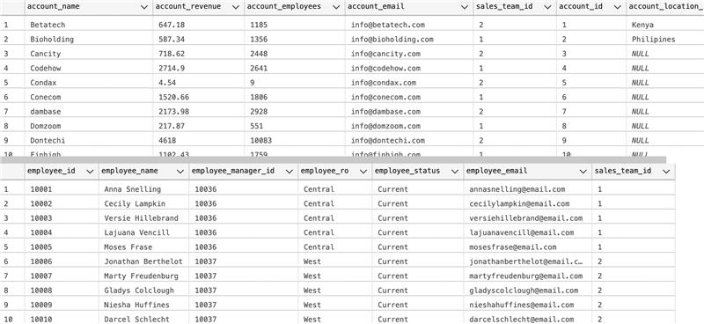

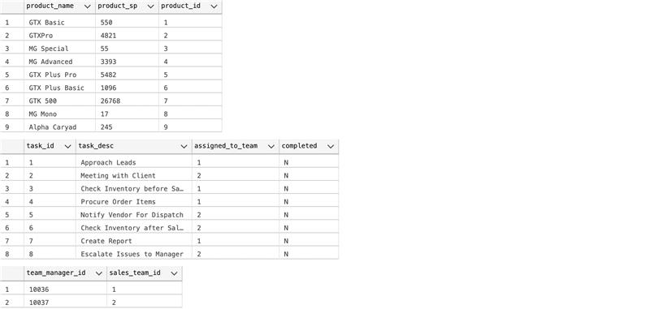

# Team Log

|  |  |
| --- | --- |
| **Team Member** | **Work Done** |
| Manan Vora | Collaborated with Aditya to make the logical model, Created Tables, Created Application Screens on Adobe XD |
| Aditya Shah | Coordinated with the team to complete the project promptly,  Collaborated with Manan to make the logical model.  Wrote the script for Up/Down for queries and inserting data into the database. |
| Amesh Gharat | Made the conceptual model,  Wrote the documentation for the project and made PPT. |